|  |
| --- |
| Circle Language Spec: Commands |

## Target Command Object in a Diagram

The principle of target command objects is explained in the article *Target Command Object*. This article demonstrates its expression in a diagram.

The target command object is the last point in a string of object redirections of command symbols.

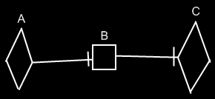

Symbol A is an active command reference to symbol B. Symbol B is an inactive command reference to symbol C. Symbol C is the target command object of both symbols A and B. Symbol C represents the command object itself.